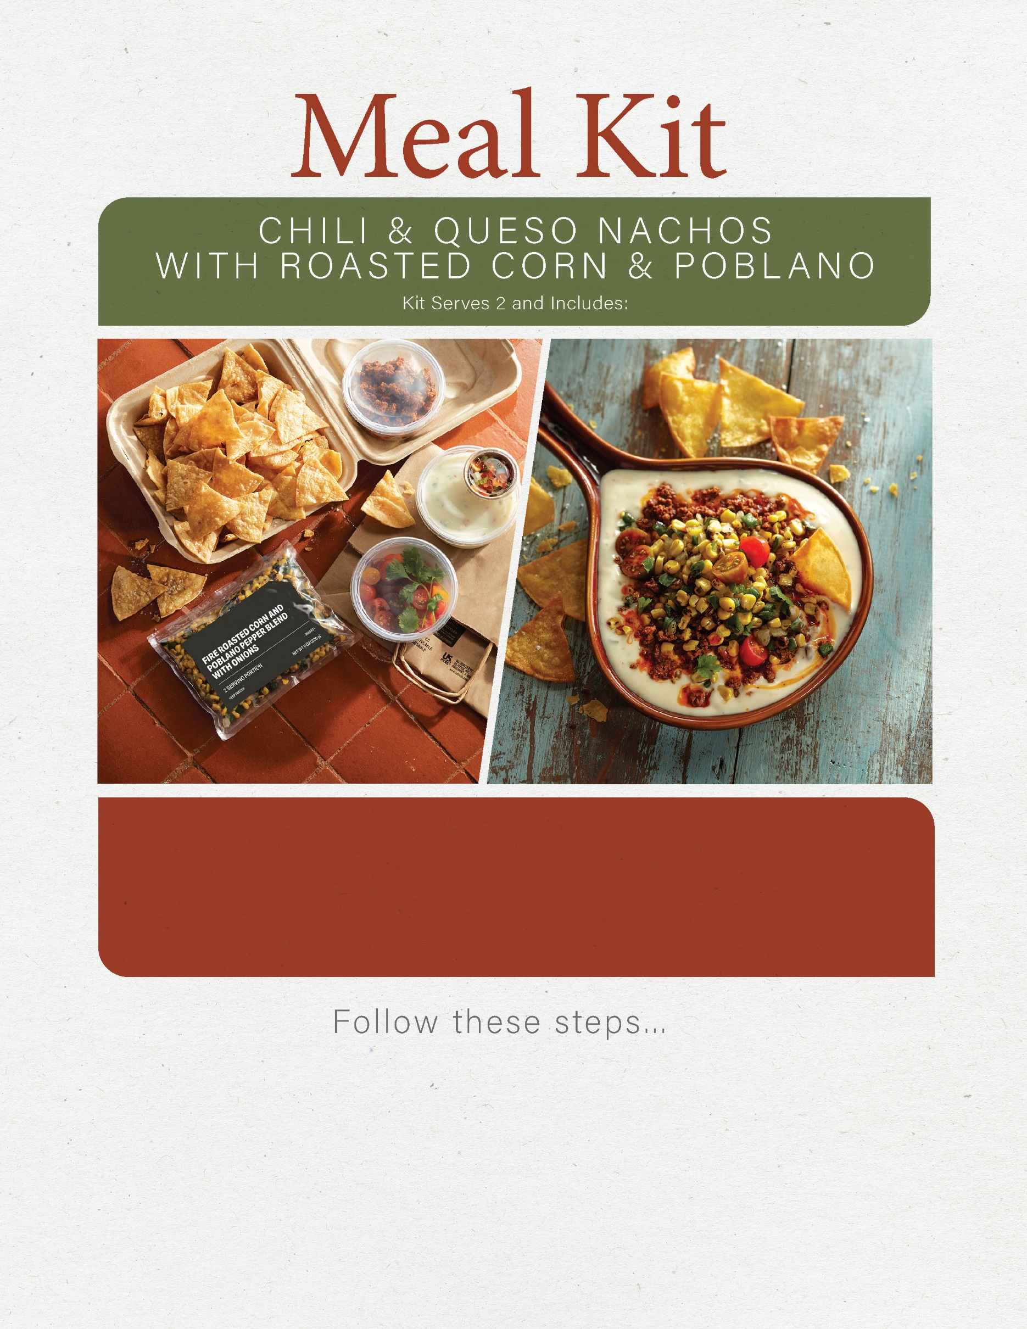

4 oz chorizo,   
cooked and drained of excess fat

1 c pico de gallo

1 c mini heirloom tomatoes

1 T cilantro

1 pouch fire roasted corn and poblano pepper blend with onions

8 oz chili con queso dip

4 c tortilla chips

1. Warm queso in microwave oven or stove top for about 2 minutes, until bubbly.
2. Cut mini heirloom tomatoes in half.
3. Warm corn and poblano blend with chorizo in a sauté pan on the stove top until hot,   
   about 2-3 minutes.
4. Top queso with heated corn, poblano and chorizo. Garnish with pico de gallo, sliced tomatoes and cilantro. Serve with tortilla chips.