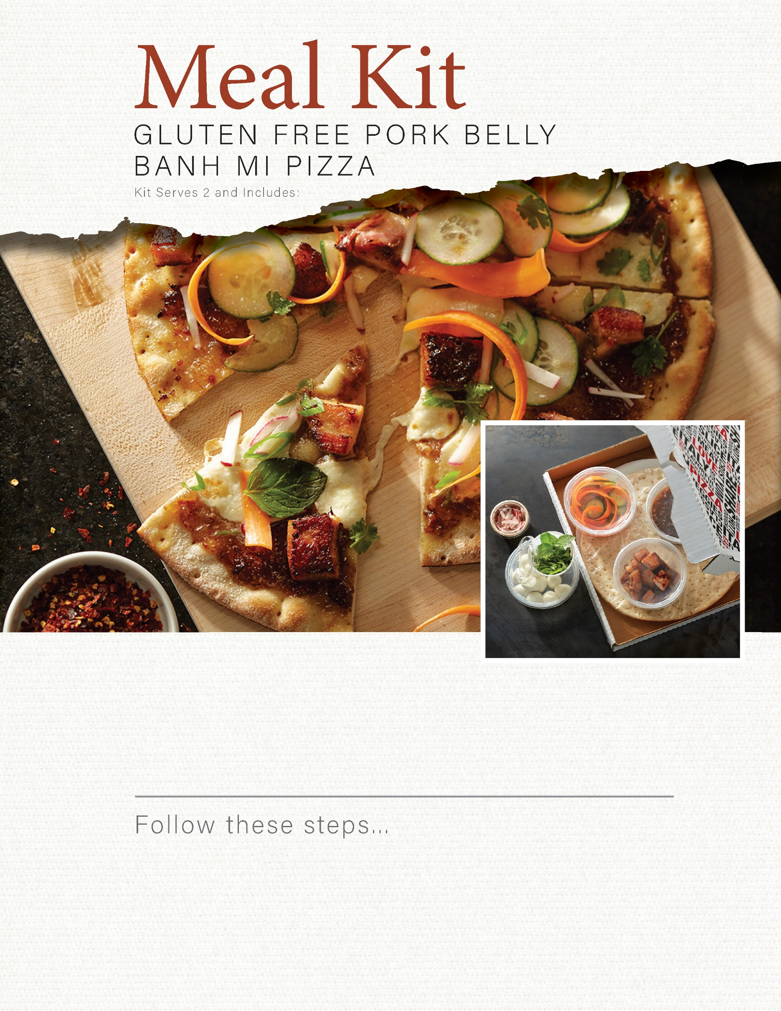

1. Unwrap pizza crust and discard plastic coated paper support disk.
2. Spread onion jam on crust, then top with fresh mozzarella and diced pork belly.
3. Bake directly on oven rack in a preheated 425°F oven for 5-7 minutes or until pork is crispy and cheese is melted.
4. Garnish with mint, basil, cucumbers, carrots, radishes and peppers. Cut into 8 pieces and enjoy!

1 gluten free Italian pizza crust

4 oz smoked diced pork belly

3 oz fresh mozzarella

4 oz balsamic red onion jam

4 oz sliced carrots

4 oz sliced radish

4 oz sliced cucumber

4 oz sliced peppers

6 fresh mint and basil leaves