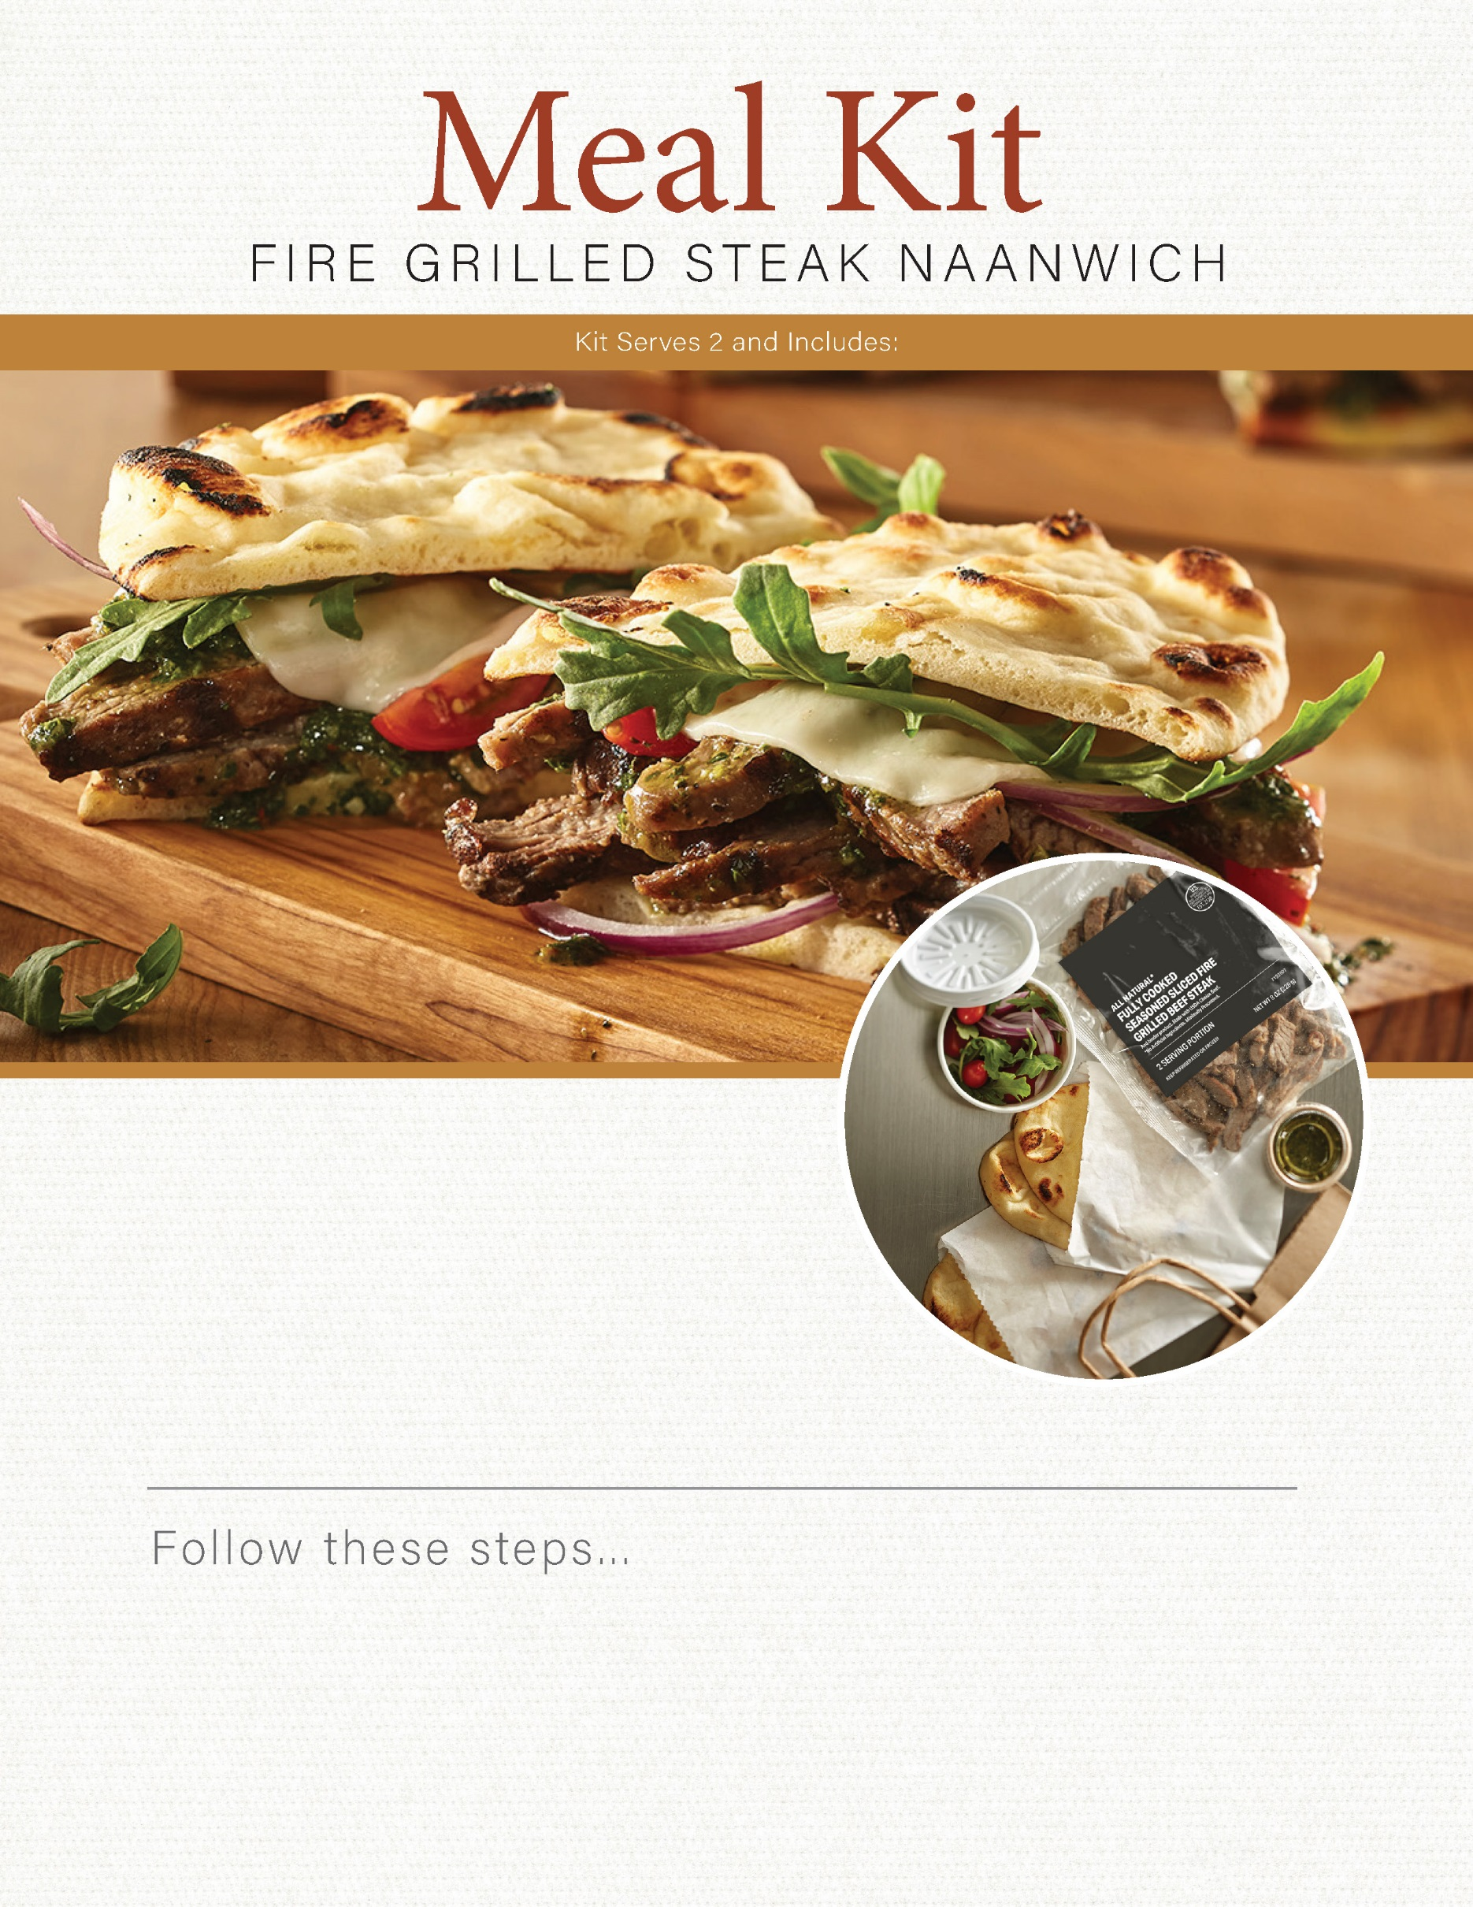

1. Warm naan bread in oven, toaster or on a griddle.
2. Sauté steak slices on a griddle or sauté pan over high heat for 1-2 minutes.
3. Cut mini heirloom tomatoes in half.
4. Assemble sandwich with pesto, greens, sliced red onions, tomatoes and warmed steak slices on warm naan bread.

1 pouch all-natural sliced fire grilled steak

4 ea mini naan bread

4 oz basil pesto

1 c spring herb salad mix or arugula

1/2 c mini heirloom tomatoes

1/4 c sliced red onions