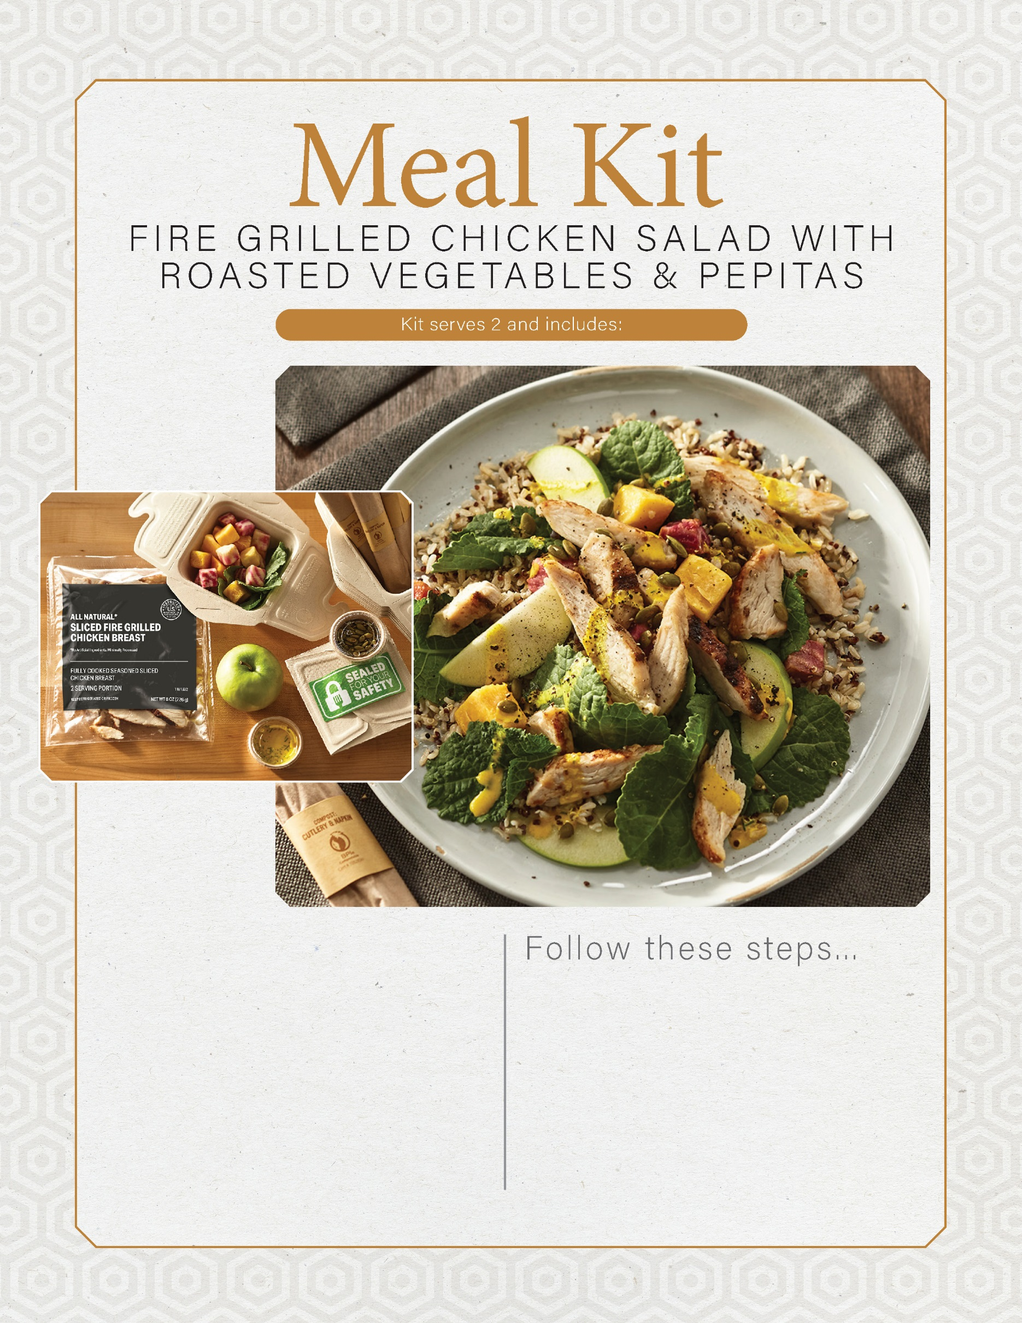

1 pouch all-natural sliced fire grilled chicken breast

8 oz roasted sunset vegetable blend

2 oz tumeric tahini dressing

2 T pepitas

1 ea green apple or green pear

2 c kale, quinoa and edamame blend

1. Slice green apple or pear.
2. Warm chicken slices over medium heat on a griddle or sauté pan for 2-3 minutes.
3. In a bowl toss kale, quinoa, sunset vegetables and apple with salad dressing.
4. Divide dressed salad between 2 bowls and garnish each with sliced chicken and pepitas.