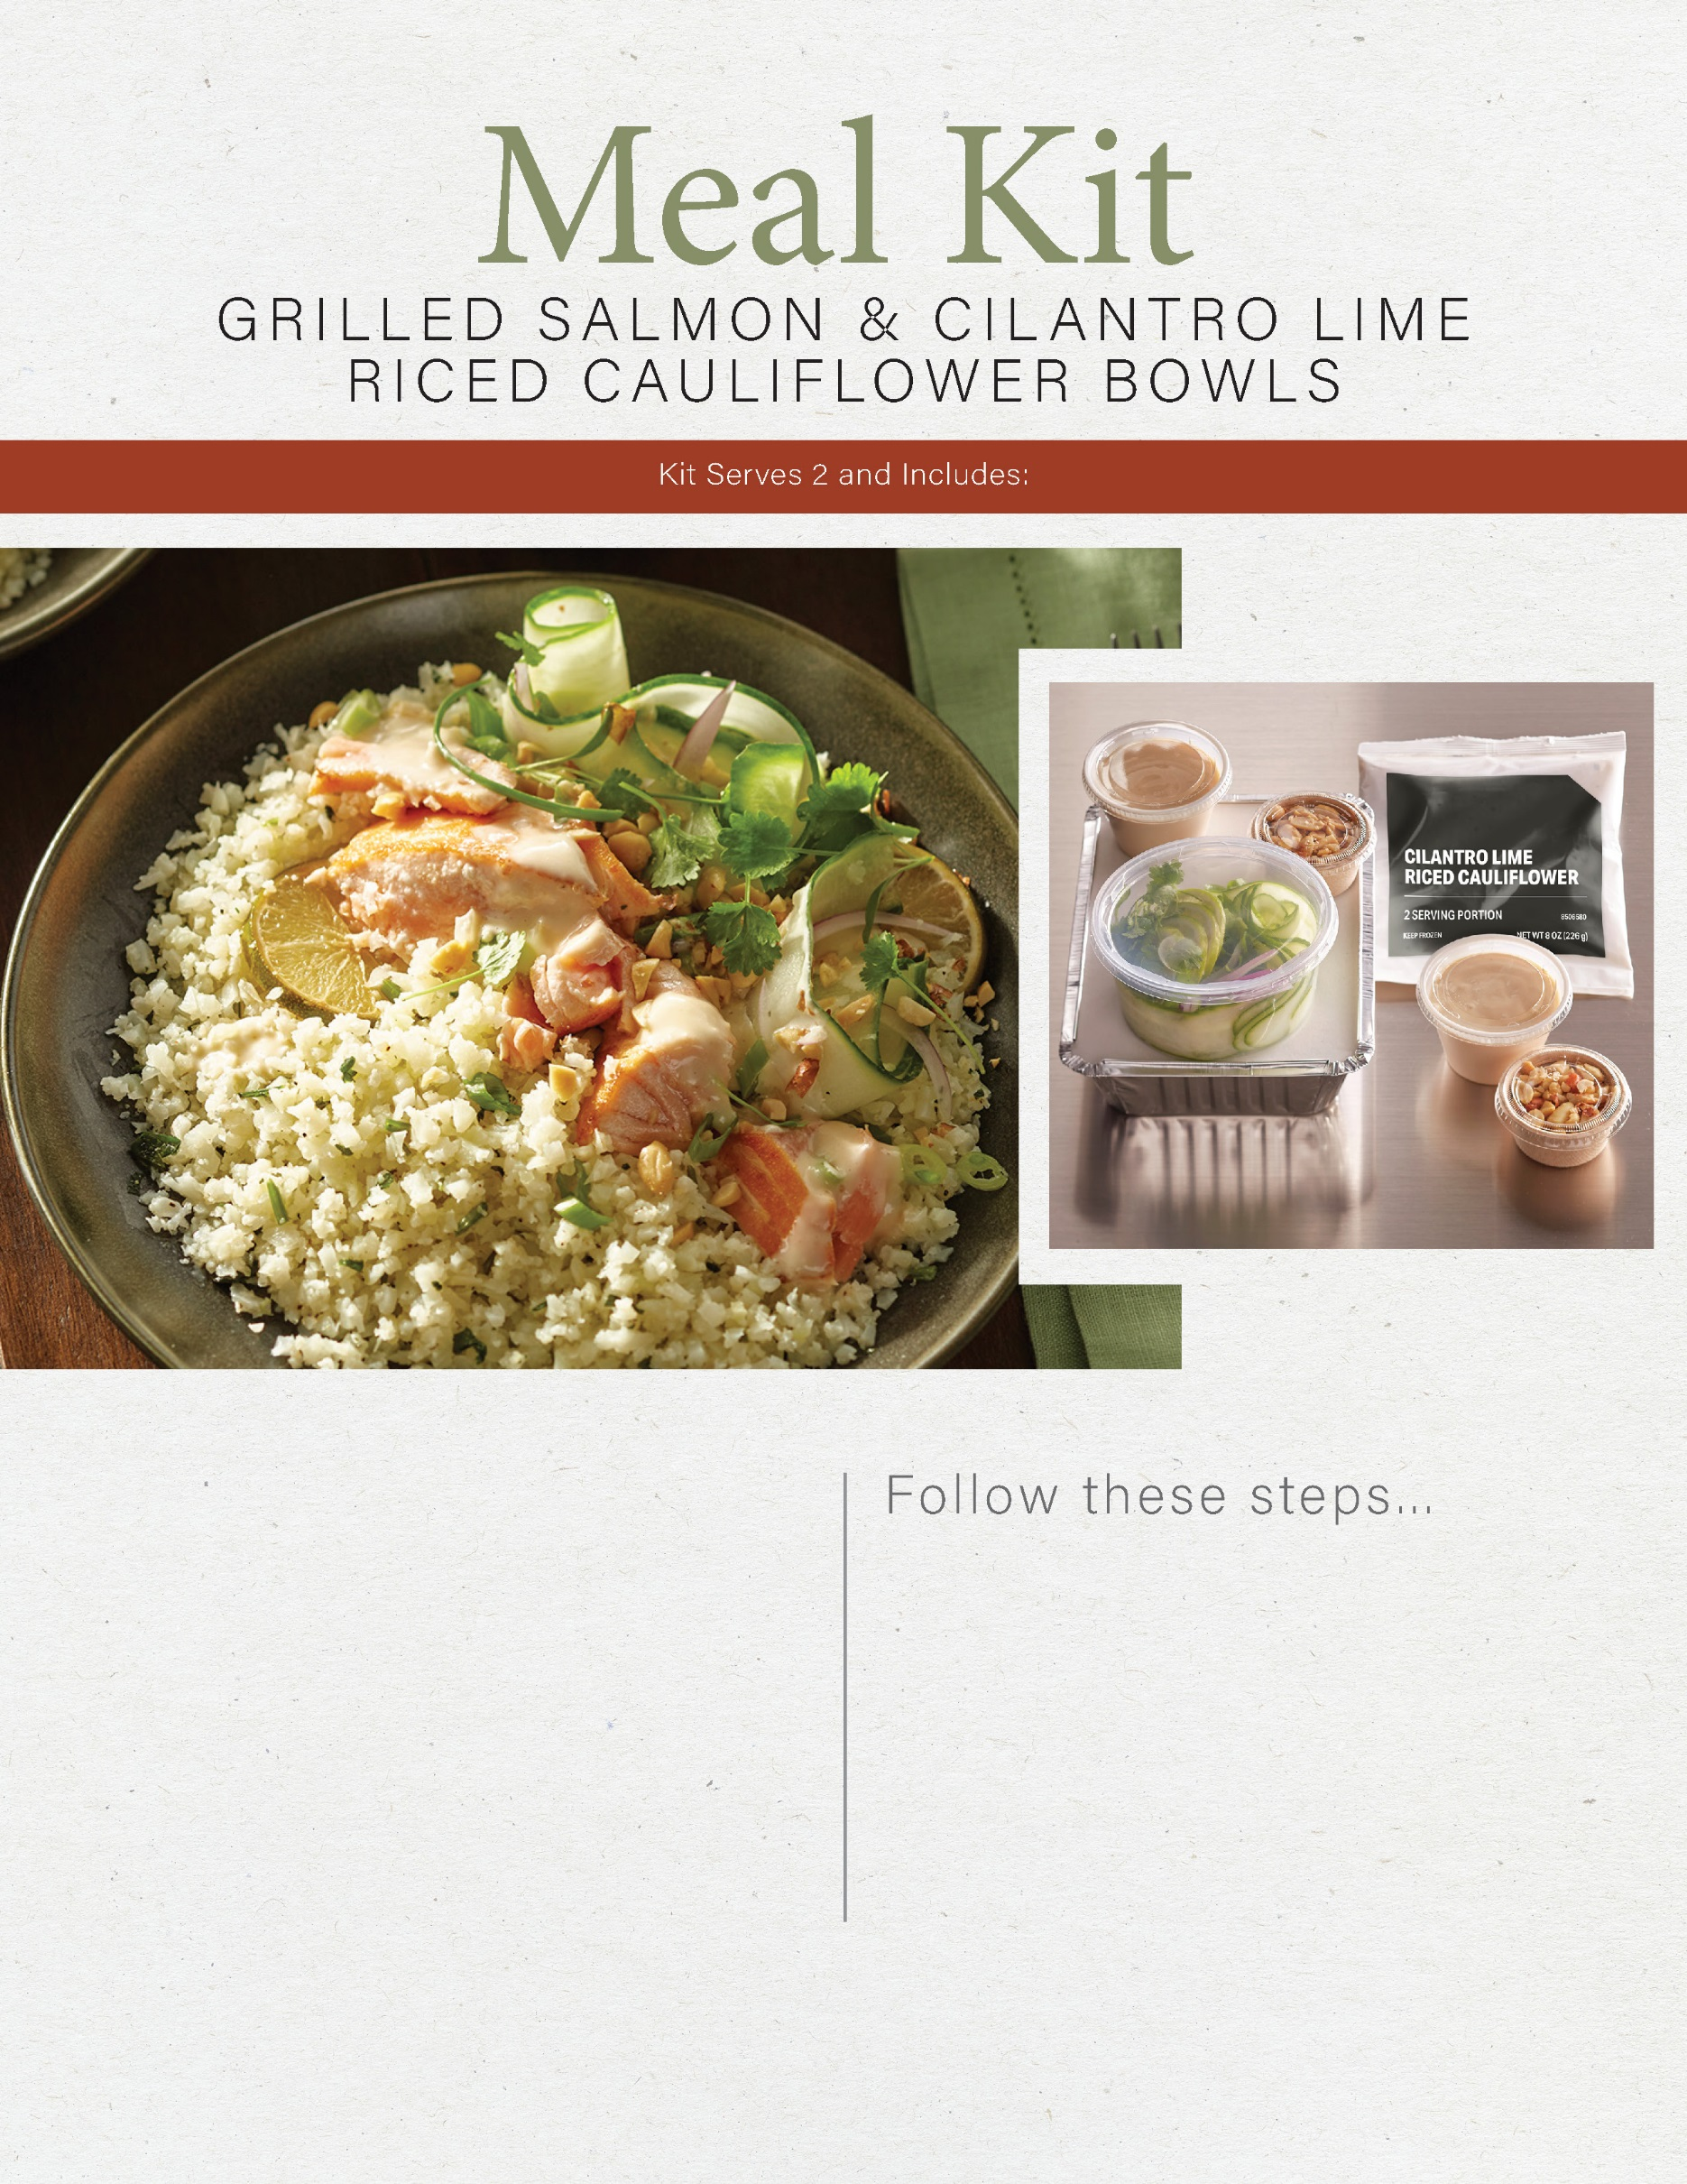

2 4-oz cooked salmon filets

1 bag cilantro lime riced cauliflower

4 oz English cucumber sliced into ribbons

4 oz red onions, sliced

4 oz Asian dressing

1 oz dry roasted peanuts, chopped

2 T fresh cilantro, chopped

2 wedges fresh lime

1. Microwave cilantro lime riced cauliflower in bag for 4-5 minutes at medium-high wattage. Do not pierce bag.

2. Reheat salmon if desired and place atop cauliflower.

3. Garnish with cucumber ribbons, onions, peanuts and lime wedge. Drizzle with dressing and enjoy.