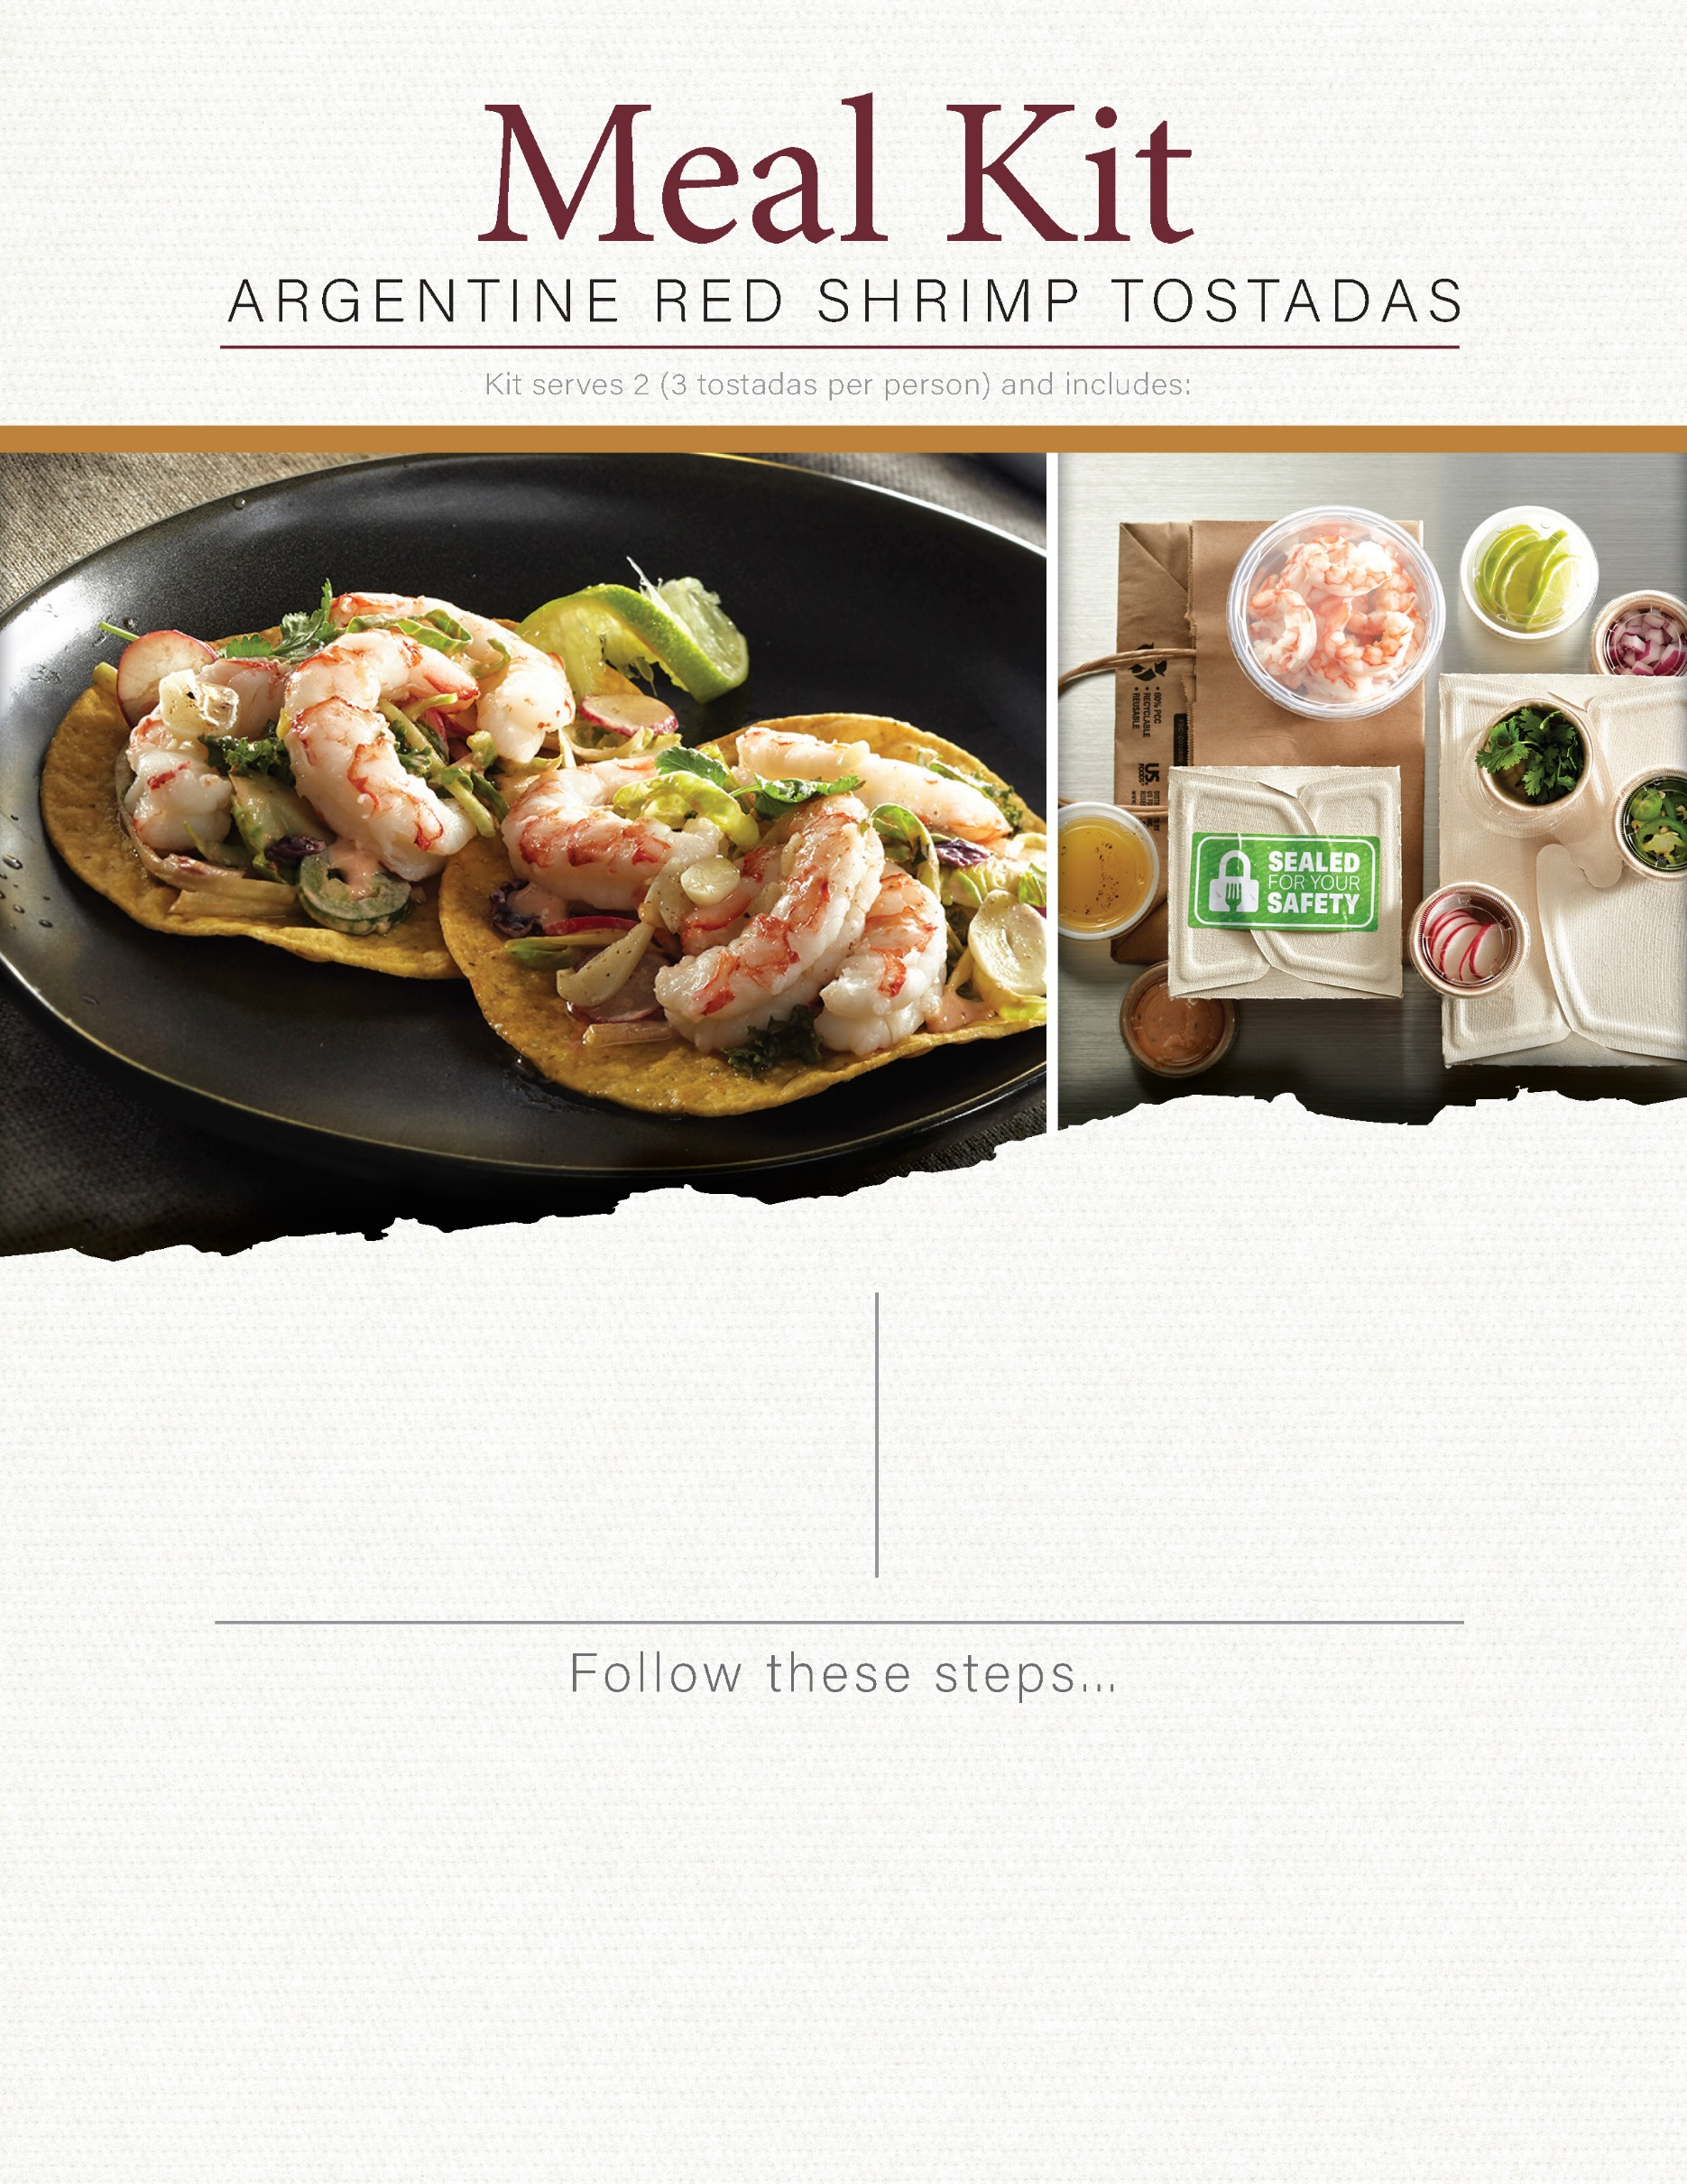

2 T chopped cilantro

2 ea sliced lime wheels

2 c superfood slaw

4 oz chipotle mayo

4 oz black beans

2 oz crumbled Cotija cheese

8 oz pre-cooked Argentine red shrimp

6 ea 6" corn tortillas

2 T sliced jalapeno

2 T sliced radish

2 T sliced red onion

1. Lightly spray both sides of tortillas with oil and bake on sheet pan in a 400°F oven for 10 minutes, flipping halfway through cooking time.
2. Warm black beans for 30 seconds in a microwave oven, then spread over prepared crispy tortilla shells, and top with crumbled Cotija cheese.
3. Combine superfood slaw, jalapenos, red onions and radishes with chipotle mayonnaise and top tostadas with slaw mixture.
4. Arrange shrimp atop slaw, garnish with chopped cilantro and lime wheels on the side and enjoy!