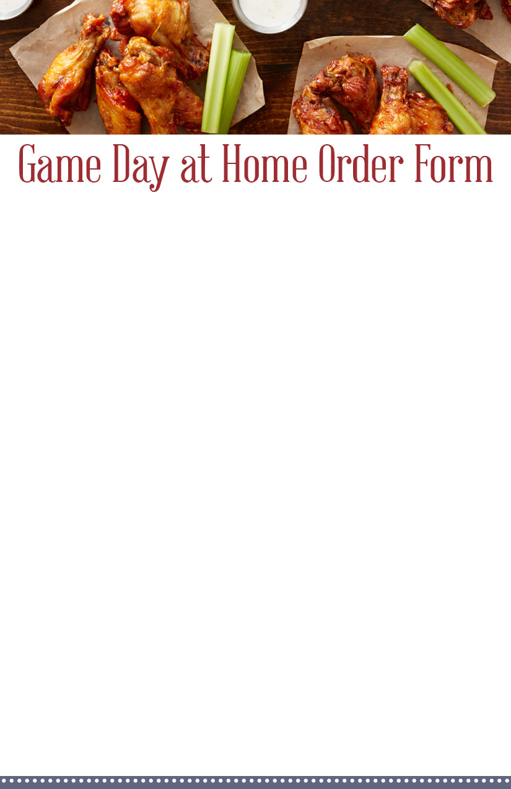­­­­­­

*Mark with an “X” all that you would like. Include # of servings desired*

***How many people in your group***

**HEADCOUNT**

***913-555-1212***

**PHONE**

***Month / Day / Year***

**PICKUP DATE**

**PICKUP TIME**

***Hour : Minute***

**YOUR NAME**

***Mr. & Mrs. Smith***

***X – 2 serv.­­­***

***X***

**Dessert Pizza**

***X***

**Item**

***X – 8 pieces***

**Fruit-Filled**

**Bombolini (per pc)**

**Extra Sauce**

**Rosemary Seasoned Fries**

**Item**

***X***

**Item**

***X – 8 serv.***

**Item**

***X***

**Mac & Cheese Bites (4 per order)**

***X – 6 serv.***

**Combo Platter**

**Onion Rings /Fries & Fried Pickles**

***X – 3 serv.***

***X – 2 serv.***

**Beef Nachos**

**Bone-In Wings**

**Hot / Med / Mild**

**Chicken Wings**

**Hot / Med / Mild**

**THE EXTRAS**

***X – 1 serv.***

***X – 4 serv.***

**THE ESSENTIALS**

***X – 2 serv.***

YOUR LOGO HERE­­