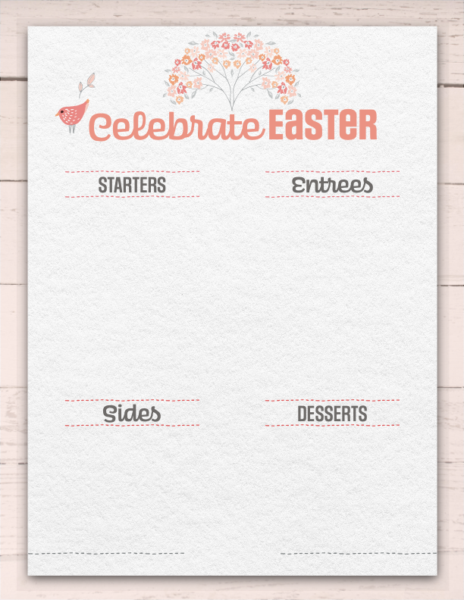­­­­­­­­­

www.website.com­

LOGO

­­

{212} 555-1212

WITH “YOUR RESTAURANT’S NAME”

item name

item name

­­­item name

item name

item name

item nameitem description item description item description item description item description item description item

item nameitem description item description item description item description item description item description

item nameitem description item description item description item description item description item description item

item nameitem description item description item description item description item description item description

item nameitem description item description item description item description item description item description item

item nameitem description item description item description item description item description item description

item nameitem description item description item description item description item description item description item

item nameitem description item description item description item description item description item description

item nameitem description item description item description item description item description item description item

item nameitem description item description item description item description item description item description