Menu Profit Pro™
Quick Start Guide

Simple Recipes & Menu Items

Contents
Introduction 3
Step 1 – Identify the most important recipes and menu items 4
Step 2 – Complete Worksheets for Recipes and Menu Items 4
Step 3 – Create Menu Item Categories 5
Step 4 - Create a Simple Recipe - Overview 6
Create Simple Recipe – Detail 7
1. Create Recipe Header 7
2. Add Ingredients 9
3. Add Recipe Instructions 10
Step 5 - Create Simple Menu Items - Overview 11
Create Simple Menu Items – Detail 12
1. Create the menu item header 12
2. Add Ingredients 14
3. Add Menu Items Instructions 15
Additional Documentation – Worksheets 16

Introduction

This Quick Start Guide is a streamlined process for setting up recipes and menu items. This process assumes the following:
- No Non-US Foods products will be used. All recipes and menu items will include only US Foods products.
- All ingredients units of measure are ounces or pounds. This will eliminate the need to enter cup weights.
- Recipes and Menu Items include instructions. For simplicity CCPs are not included.

- Identify the most important recipes and menu items.
Start off with your most popular items first so that you are working on the recipes and menu items that can benefit most from MPP's analysis.

- Fill out worksheets for recipes and menu items.
Completing a worksheet helps to identify ingredients that may require additional steps prior to adding them.
- Create menu item categories.
Menu item categories are used to group similar menu items together, such as appetizers, salads, entrees etc. for the purpose of analysis and comparison.
- Create Simple Recipes
Use only ingredients from the USF product catalog. Create recipes that are used in the top menu items.
- Create Simple Menu Items
Use only ingredients from the USF product catalog. Create menu items the top menu items sold by the customer.

Step 1 – Identify the most important recipes and menu items

Before starting work with MPP, we recommend that you consider the eighty-twenty principle. This principle is based on the concept that in general, 20% of the items on any menu produce approximately 80% of the revenue.

By focusing on these items, you will ensure that your initial work will have the greatest impact. Additional items can be added later as desired. This also lets you learn MPP without having to take on the task of entering all of your recipes and menu items before realizing the benefits of the program.

In general, it’s best to examine sales reports from the point-of-sale system to determine the top selling menu items. For recipes, look for those that are used within your top menu items, Make a note of these to enter them into MPP first.

Step 2 – Complete Worksheets for Recipes and Menu Items

Recipe and menu item worksheets are Microsoft Word documents you can use to list all ingredients and preparation steps. Use the Recipe Worksheet form to enter the ingredients needed for the recipe. Include quantity and unit of measure. Non US Foods products should be replaced with US Foods products.

Recipe and Menu Item worksheet can be downloaded from: http://www.usfoods.com/content/www/home/menu-profitbuilder-pro-training.html .
See ‘Reference Materials’ at the bottom of the screen. Blank copies are also attached at the end of this document.

This example creates a recipe for lasagna.
- Enter the recipe basic information.
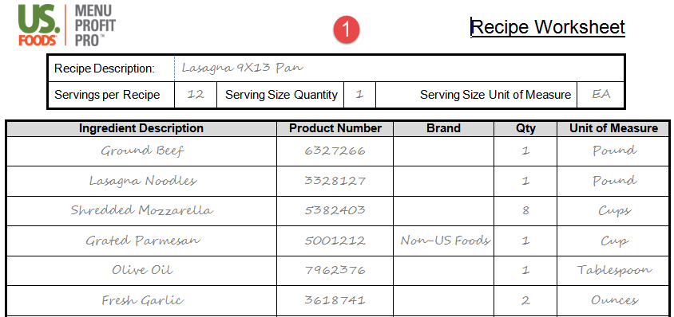
- Enter the ingredients needed for the recipe including the quantity and unit of measure.

Enter the name of the first instructional step. In this example the step will be entered as “Instructions”

- In this example the step will be entered as “Instructions”
- Enter all of the preparation/handling directions to be included in this step.
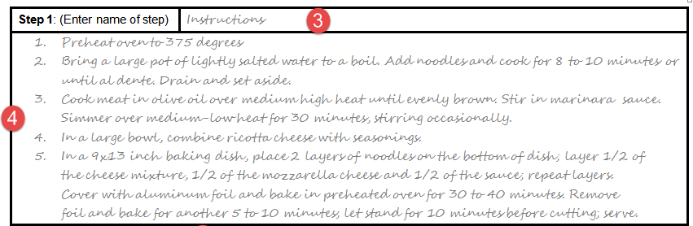

Step 3 – Create Menu Item Categories
Menu Item Categories allow you to group Menu Items into common groups – such as Appetizers, Entrees and Desserts.

You can enter new categories, modify existing categories and customize the list to match any foodservice operation. The information appears on the Menu Item Categories list, on Menu Items and on the Menu Items list.

You add and define new menu item categories in the Menu Item Categories window. Including low and high target settings to create ranges for food cost percentages and gross profit dollars.
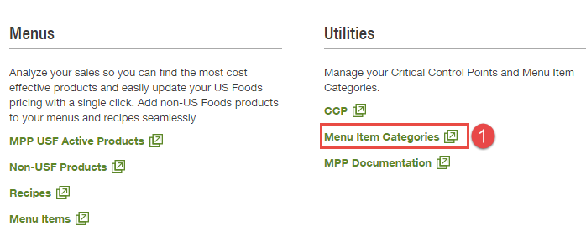
- Begin by clicking on ‘Menu Item Categories’ under the menu tab on USFood.com.
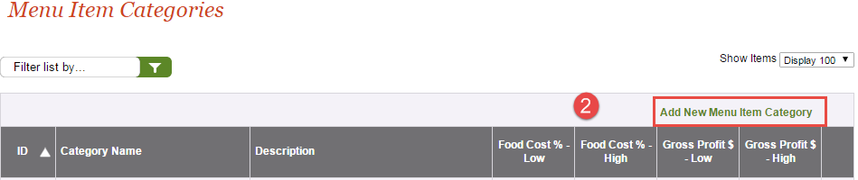
- Click on ‘Add New Menu Item Category’ to create a new category.
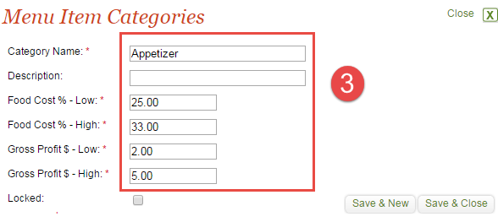
- The Menu Item Categories box will appear. Enter the category name, description, desired high and low food cost percentage, and gross profit dollars. MPP provides defaults based on common industry standards, but these may be changed to suit your specific business.

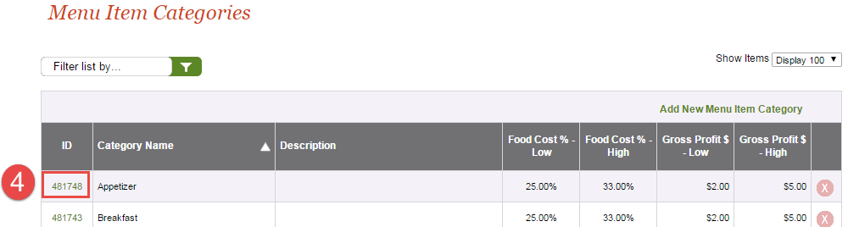
- Once added, Menu item categories and details appear on the Menu Item Categories list (with a unique, auto-assigned identification number). To edit a category, click the menu item category ID to open the Menu Item Categories details window.

Step 4 - Create a Simple Recipe - Overview

Creating a simple recipe consists of three steps:
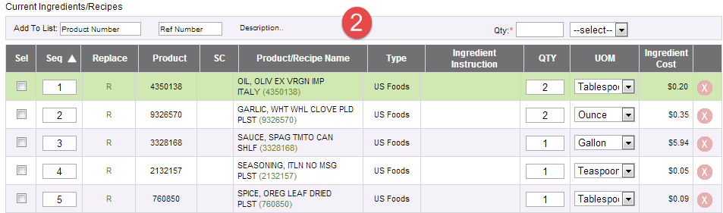
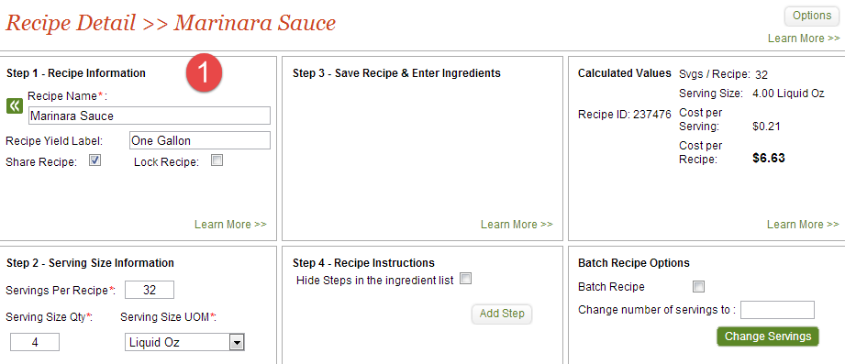
- Create the recipe header
This is the key information about the new recipe. Ingredients cannot be added until the header is created and saved.

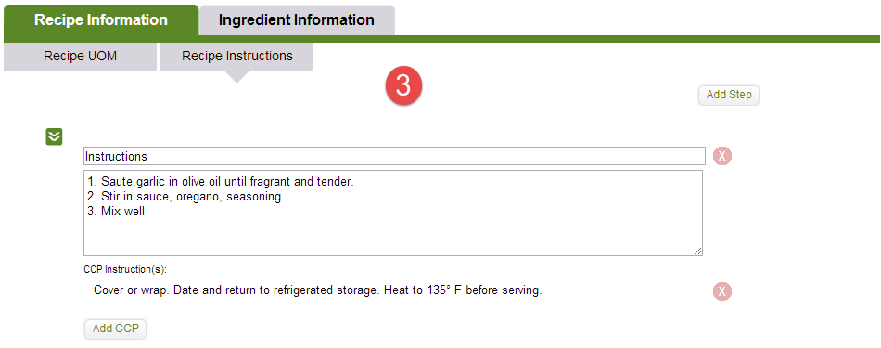
- Add ingredients – Since MPP Online is fully integrated with USFood.com, any product stocked by the division can be added as an ingredient. The user adds ingredients to a recipe the same way that they add them to an order – by searching the full product catalog or keying in the product number.
- Enter instructions – Instructions can be added at any time. You can also add instructions to groups of ingredients. This step also allows inclusion of Critical Control Points (CCP)

Create Simple Recipe – Detail

Create Recipe Header

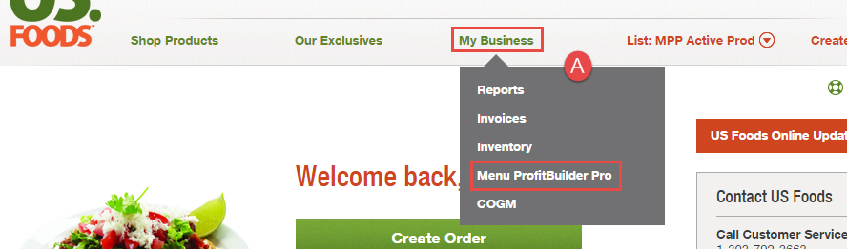
- From the main menu on USFood.com, click on My Business, and click Menu Profit Pro™.
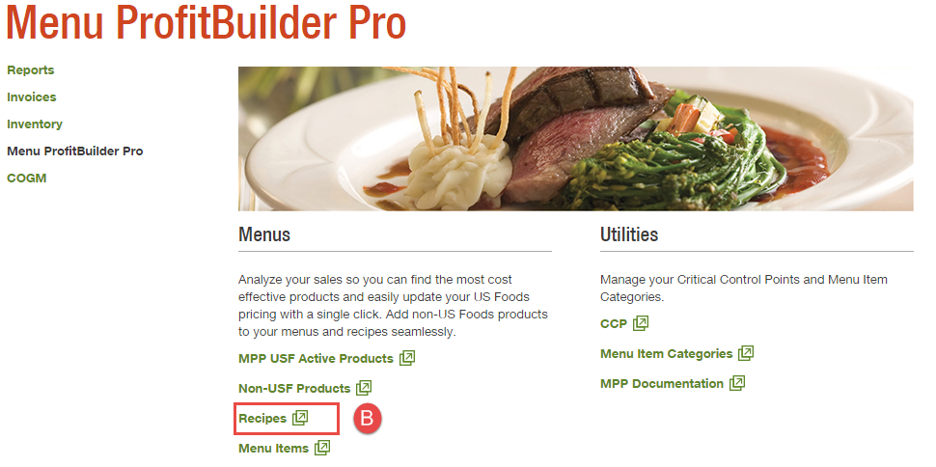
- The MPP Landing page appears. Click on Recipes.
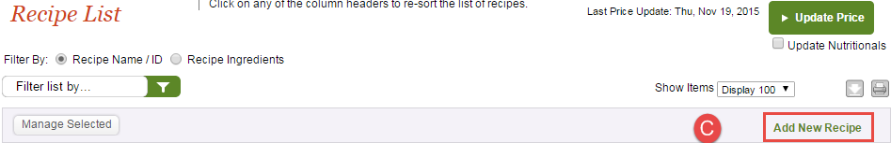
- The Recipe List screen will appear. Click on Add New Recipe.

- The Recipe Detail screen will appear.
Enter all of the required information in steps 1 and 2. For serving size, you may enter the lowest common serving size, such as 1 ounce. You may also enter a serving size such as 4 ounces or 1 cup etc. Be sure your servings per recipe are consistent with your serving size. Click on the Save button in step 3. Ingredients cannot be added until the recipe header information is saved.
- Click the Save Recipe button.
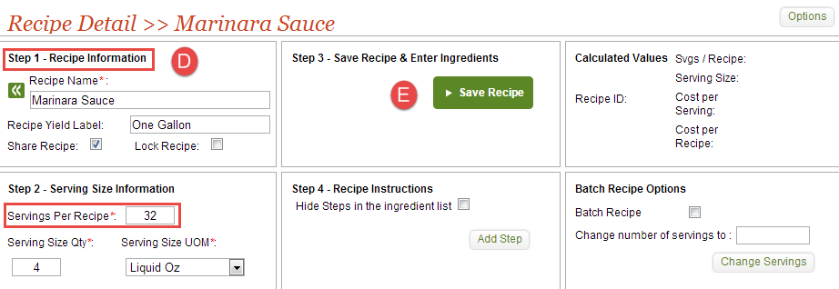
- The screen will refresh. The save button will disappear and the ingredient column headers will appear in the bottom half of the screen.
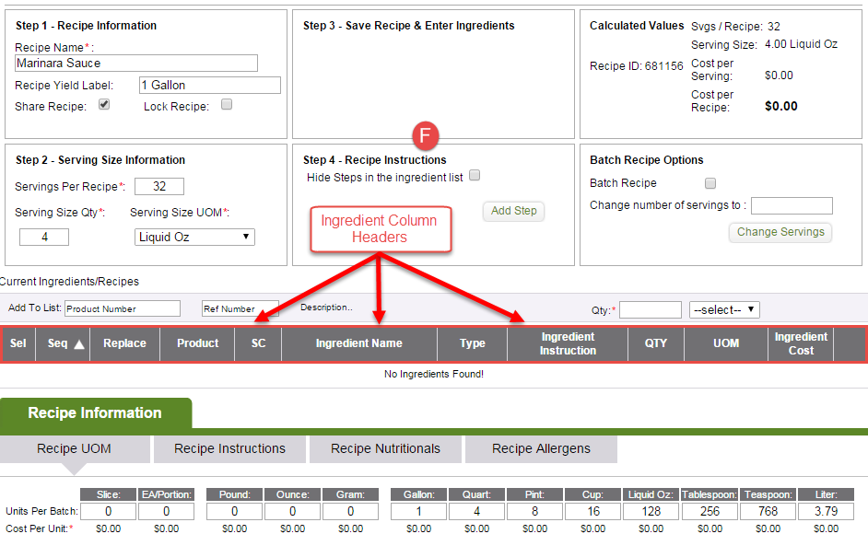

Note: When you enter the Serving Size and Servings per Recipe it will automatically populate this information on the Recipe Unit of Measure (UOM) portion of the screen. HINT: When using only Volume, Slice or Each/Portion - Be sure to add the weight of the recipe to the recipe units of measure as well.

Add Ingredients

There are two ways to enter US Foods ingredients. You can key the product numbers using the Zip Add feature or search the product catalog.

Zip Add

- Key the product number using ‘Zip Add’
- Key the product number into the Product Number field. Press Enter or the tab key. The product description will appear. Enter the quantity and unit of measure. Click on the Add button.
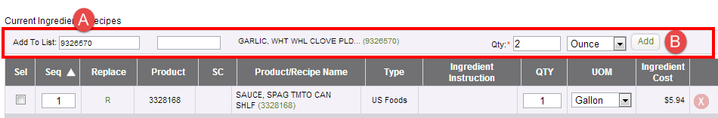
Search the product catalog

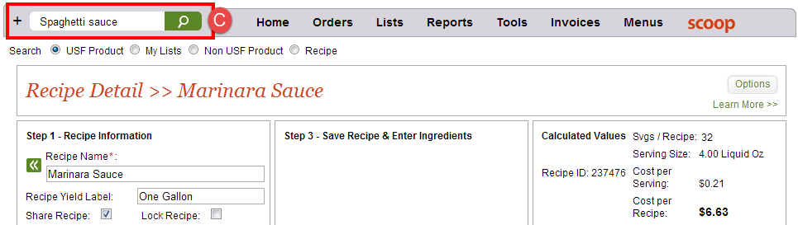
- Enter the ingredient name in the Search field. Select Search USF Product or Search My Lists. Click on the search icon or press the Enter key.
- The search results screen will appear. Select the product to add to the recipe by entering the qty and UOM. Click on Add to Recipe.

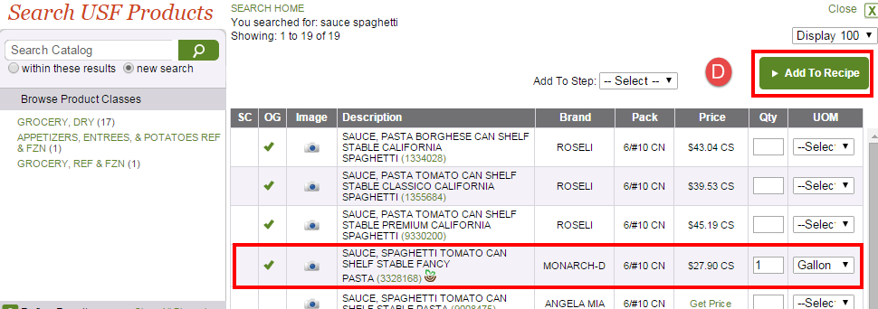

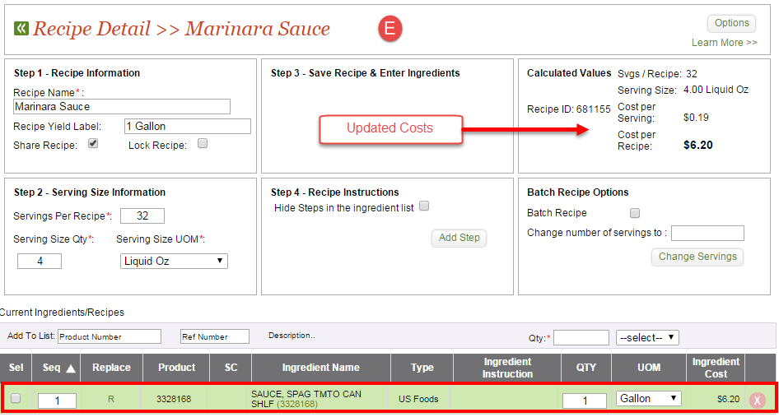
- The product will be added to the recipe and the recipe detail screen will reappear. All of the cost fields will update with the ingredient cost information. Continue adding the remaining ingredients to the recipe.

Add Recipe Instructions

- On the Recipe Detail screen, select the ‘Recipe Information’ tab, and the sub tab ‘Recipe Instructions.’ This will open the Recipe Instructions screen.
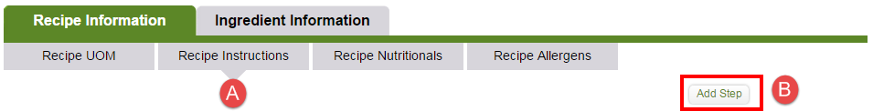
- Click on the ‘Add Step’ button to add the first step.
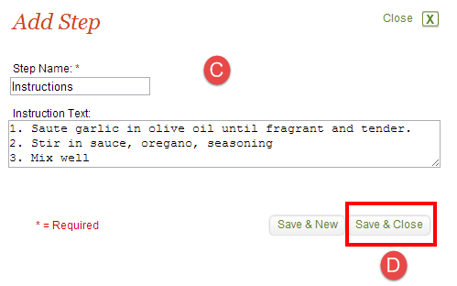
- For simplicity only one step will be added. This will open the ‘Add Step’ dialog box. Name the step. In this example the step will be called Instructions. Enter the Instruction text.
- Click “Save & Close”.

- The step and its instructions now appear in the recipe instructions portion of the screen.

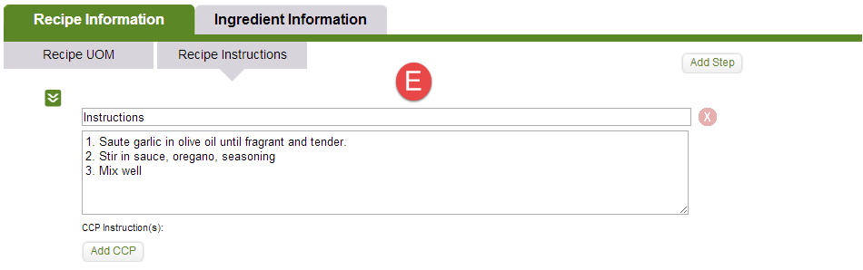

Step 5 - Create Simple Menu Items - Overview

Creating a simple menu item consists of three steps:
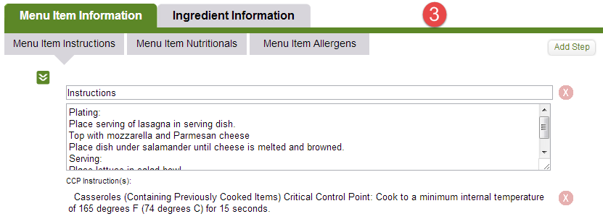
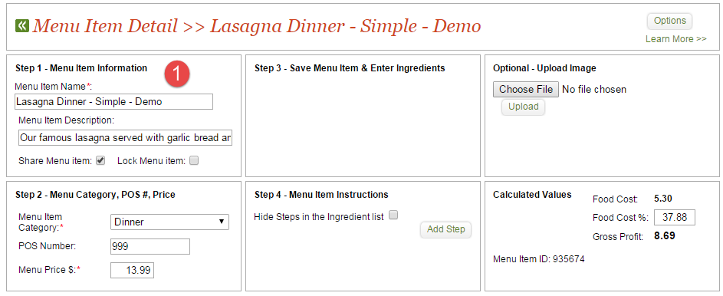
- Create the menu item header
This is the key information about the new menu item. Ingredients cannot be added until the header is created and saved.

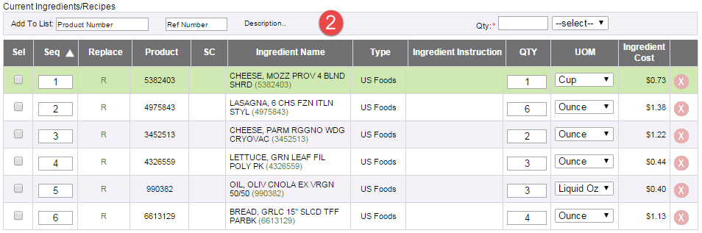
- Add ingredients – Since MPP Online is fully integrated with USFood.com, any product stocked by the division can be added as an ingredient. The user adds ingredients to a menu item the same way that they add them to an order – by searching the full product catalog or keying in the product number.
- Enter instructions – Instructions can be added at any time. You can also add instructions to groups of ingredients. This step also allows inclusion of Critical Control Points (CCP)

Create Simple Menu Items – Detail

Create the menu item header

    - From the main menu on US Foods Online, hover over the “My Business” tab and select Menu Profit Pro.
    - Click on Menu Items.
    - The Menu Items list screen will appear. Click on Add New Menu Item.
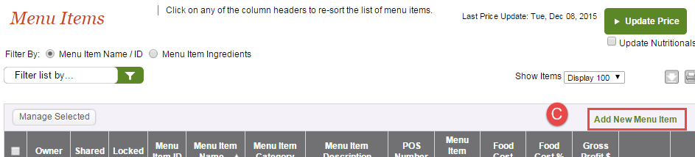

    - The Menu Item Detail screen will appear.
    - Enter the Menu Item Information*. Required fields are marked with a red asterisk.
    - Enter Menu Category, POS #, and Price details.
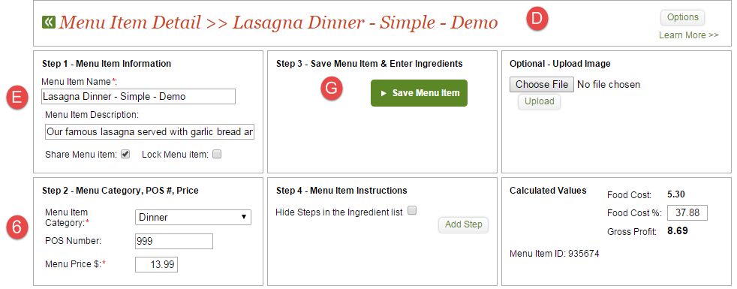
    - Click on ‘Save Menu Item’ to save the menu item header. The header must be saved before the user can add ingredients or recipes.

- When the ‘Save Menu Item’ is clicked, the following screen changes will occur:

    - Search options will appear
    - Save Menu Item button will disappear.
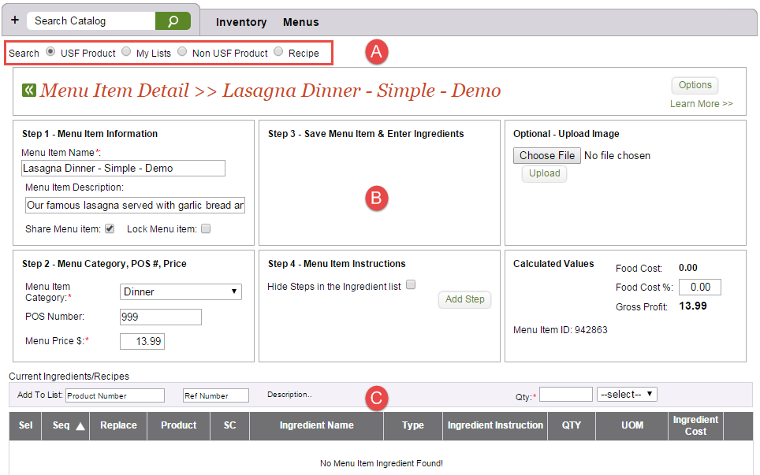
    - Current Ingredients/Recipes section will appear. Ingredients can now be added to the menu item.

Add Ingredients

There are two ways to enter US Foods ingredients. You can key the product numbers using the Zip Add feature or search the product catalog.

Zip Add

- Key the product number in the ‘Add to List’ window.
- Key the product number into the Product Number field. Press Enter or the tab key. The product description will appear. Enter the quantity and unit of measure. Click on the Add button.
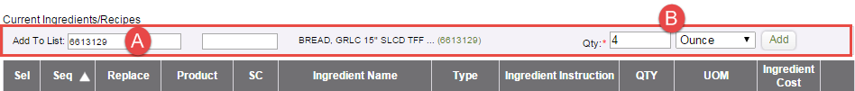
Search the product catalog

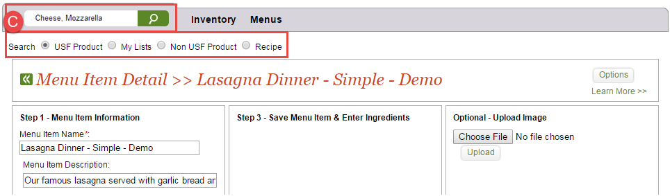
- Enter the ingredient name in the Search field. Select Search USF Product or Search My Lists. Click on the search icon or press the Enter key. The search results screen will appear.
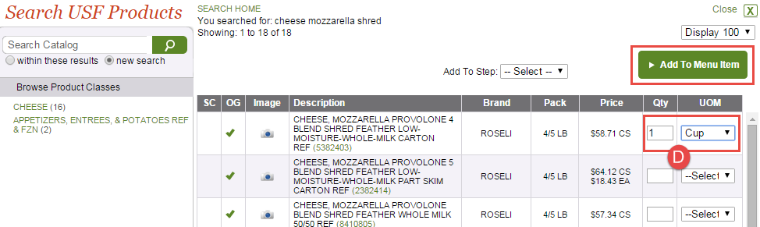
- The search results screen will appear. Select the product to add to the menu item by entering the qty and UOM. Click on Add to Menu Item.

- The product will be added to the menu item
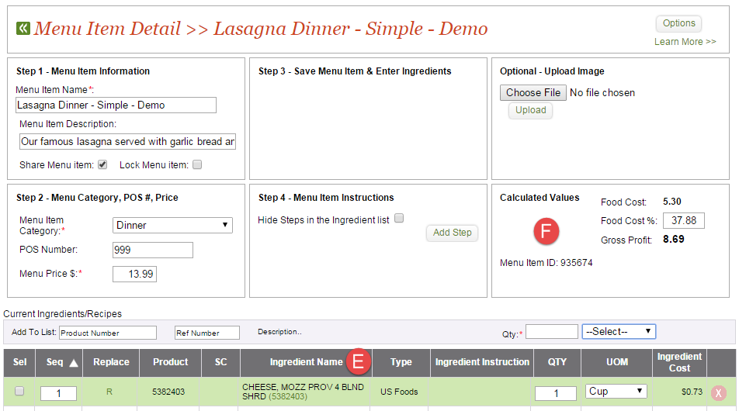
- The menu item detail screen will reappear with all of the calculated values updated
G. Continue adding USF Products to the menu item.
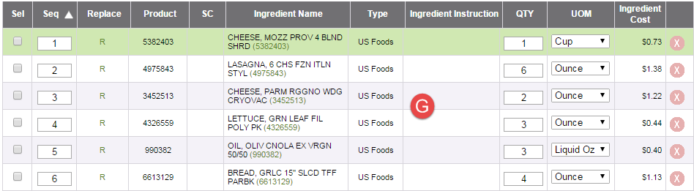

Add Menu Items Instructions

After all ingredients have been entered the user now enters instructions on menu item preparation.

- On the Menu Item Detail screen, select the ‘Menu Item Information’ tab.
- Click the sub tab ‘Menu Item Instructions’. This will open the Instructions screen.
- Click the ‘Add Step’ button to add the first step.
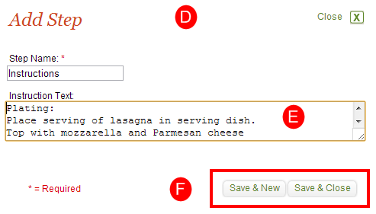
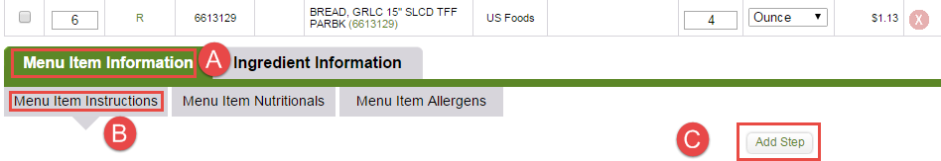

- This will open the ‘Add Step’ dialog box.
- Name the step, and enter the instructional text.
- Click ‘Save & New’ if you would like to enter another step, or ‘Save and Close’ if you are finished entering Menu Item instructions.

- The step and its instructions now appear in the recipe instructions portion of the screen.
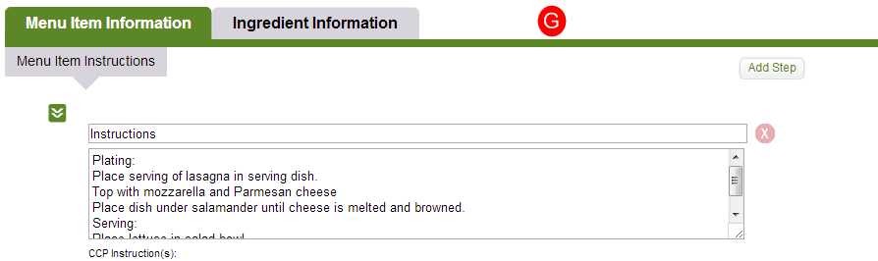

Congratulations! You have now completed the Quick Start Guide for MPP online.

If you have additional questions, or wish to view other MPP user guide documents, please contact your US Foods Sales Representative or visit our online training website;
http://www.usfoods.com/your-business/us-foods-online-training.html

Additional Documentation – Worksheets
The following two pages are the Recipe and Menu Item worksheets referenced in Step 2 on page 4 above.

Recipe Worksheet

Recipe Description:
Servings per Recipe |  | Serving Size Quantity |  | Serving Size Unit of Measure

Ingredient Description | Product Number | Brand | Qty | Unit of Measure

Step 1: (Enter name of step)
Optional CCP:
Step 2: (Enter name of step)
Optional CCP:
Step 3: (Enter name of step)
Optional CCP:

Menu Item Worksheet
Menu Item Name
Menu Item Category
POS Number |  | Menu Price

Ingredient Description | Product Number | Brand | Qty | Unit of measure

Step 1: (enter name of step)
Optional CCP:

Step 2: (enter name of step)
Optional CCP:

Step 3: (enter name of step)
Optional CCP:

